Logistic Regression:
The goal of this lecture is to solve a simple classification problem using logistic regression. Previously, we explored linear regression, particularly through examples like predicting home prices. Linear regression is effective for predicting continuous values, such as weather conditions or stock prices.
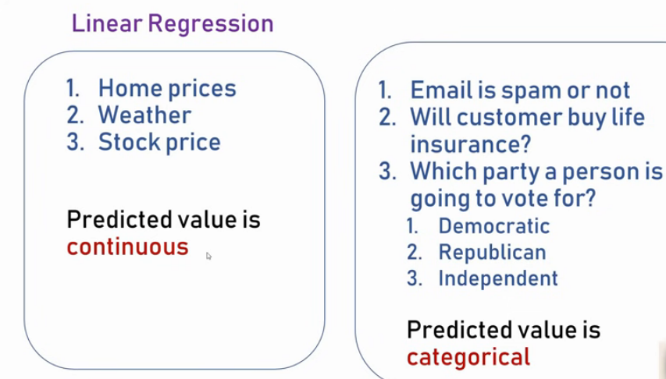
However, some problems involve categorical outcomes, like:
- Predicting whether an email is spam or not.
- Determining if a customer will buy a life insurance product.
- Identifying which political party a person will vote for.
In these examples, the prediction is categorical, meaning the output belongs to a specific set of categories. For instance:
- In the first two examples, the outcome is a simple yes or no.
- In the third example, the outcome is one of several possible categories.
In contrast, linear regression predicts any numeric value, as seen in the home prices example.

Classification Problems
Problems where the prediction is categorical are called classification problems. Logistic regression is the machine learning technique used to address these problems.

Types of Classification:
- Binary Classification:
When there are only two possible outcomes (e.g., yes or no).
Example: Predicting whether a customer will buy insurance.
- Multiclass Classification:
When there are more than two possible outcomes.
Example: Predicting which political party a person will vote for.

Email text | Spam or non-spam (binary classification)
News………………………..r | Real or fake
Text------------------- | Hate speech or neutral
Product reviews……… | Positive---negative--------neutral (multi-class classification

Logistic Regression Example: Predicting Insurance Purchases
Imagine you are a data scientist at a life insurance company. Your task is to predict how likely a customer is to buy insurance based on their age.
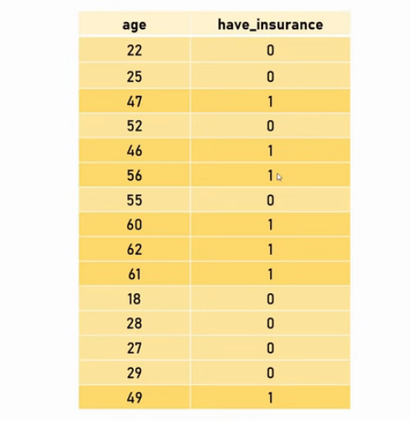

Observations from the Data:
- Younger people (e.g., ages 22, 25) are less likely to buy insurance.
- Older individuals are more likely to buy insurance.
Our goal is to build a machine learning model that predicts this likelihood of buying insurance based on the age of potential customers.

First Steps: Linear Regression Attempt
The first step is to plot a scatter plot of the data. As someone familiar with linear regression, you might be tempted to apply it here.

Applying Linear Regression:
- Draw linear equation line using the linear regression to separate "yes" and "no" predictions.
- We can predict the value using linear equation line (Predictor).
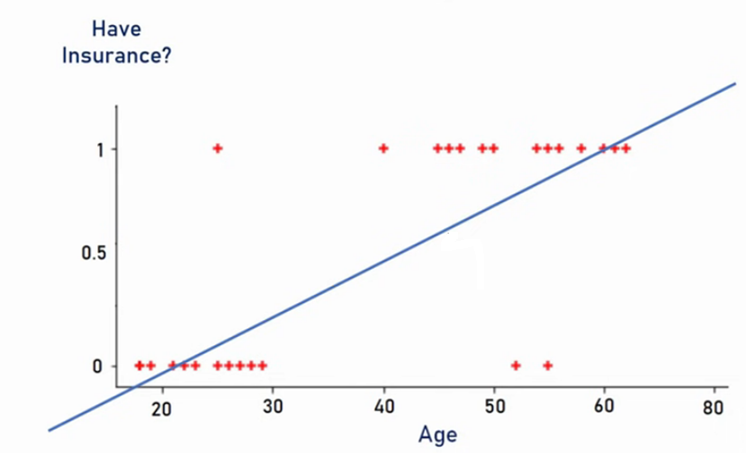
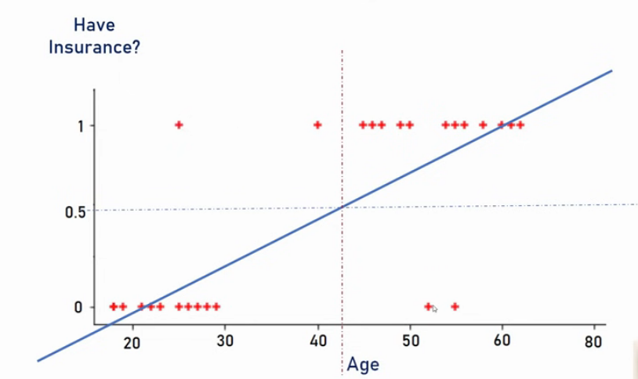

  - (Anything on RHS is yes and No on LHS)
- Use a threshold value (e.g., 0.5):
  - Predictions or predictor value is above 0.5 = yes (customer buys insurance).
  - Predictions below 0.5 = no (customer doesn’t buy insurance).
  - Few outliers, but for 90 % cases, linear regression works ok
  - Vertical line shows that approx, at the age of >= 42, person will start buying insurance. Note: on Y axis, 1 means person will buy insurance and 0 means not

Misclassification with Linear Regression

Scenario: Outlier on the Right
Imagine a data point far on the right-hand side of the scatter plot—for example, a very aged customer in your dataset(outlier) over 80 years old who purchased insurance. When this new data point is added, the scatter plot adjusts to include it, and the linear regression line shifts accordingly.

Problem with Threshold Separation
- When u draw a boundary line with 0.5, we end up misclassifying certain points.
- Using a threshold value of 0.5 to separate categories causes issues.
- Some data points, where the actual outcome is yes (e.g., the customer bought insurance), are incorrectly predicted as no. These are misclassified data points.
- Age Criteria now gone up, anyone with the age >=48, will buy insurance

Limitation of Linear Regression for Classification
This misclassification demonstrates a key limitation of linear regression: it struggles to handle categorical boundaries effectively. As a result, it is not ideal for solving classification problems where precise boundaries are required to separate categories.
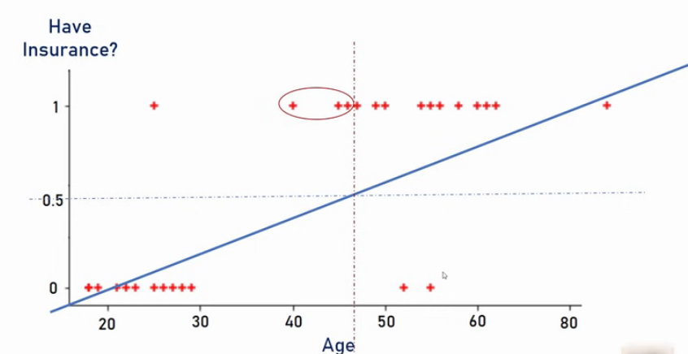
An outlier in the above context is a data point that significantly deviates from the general pattern or trend of the other data points in the dataset. It is unusual or unexpected compared to the rest of the data.
In this specific example:
- Most younger people (e.g., in their 20s or 30s) do not buy insurance, and the likelihood of purchasing increases gradually with age.
- A customer over 80 years old who did purchase insurance does not follow the typical trend of the dataset and is located far to the right in the scatter plot.
This makes the 80-year-old customer's data an outlier, as it is far from the majority of the other points and influences the behavior of the regression model in a way that highlights its limitations for classification tasks.
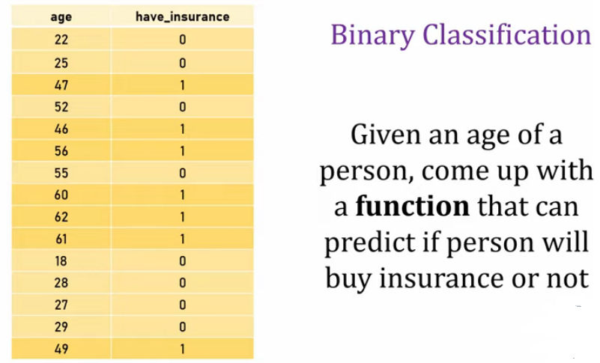

Improving the Model Fit
Let’s move to the most interesting part: imagine drawing a new line that fits the data much better than the previous linear equation. This improved line allows you to clearly separate the categories using a threshold value of 0.5, making the model perform significantly better compared to the earlier approach.
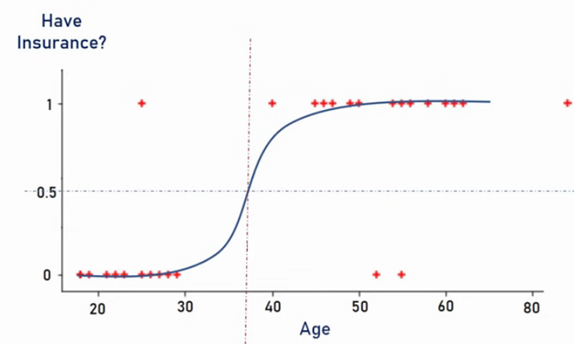

Introduction to the Sigmoid Function
The sigmoid function is a mathematical function that converts any input values into a range between 0 and 1. When plotted on a 2D chart, the sigmoid function creates an S-shaped curve.
In logistic regression, we use this S-shape to transform a linear equation into a classification model.

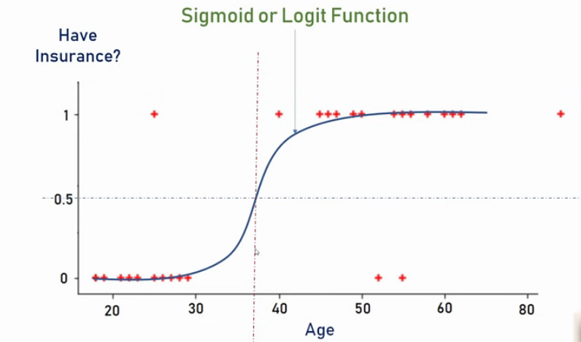

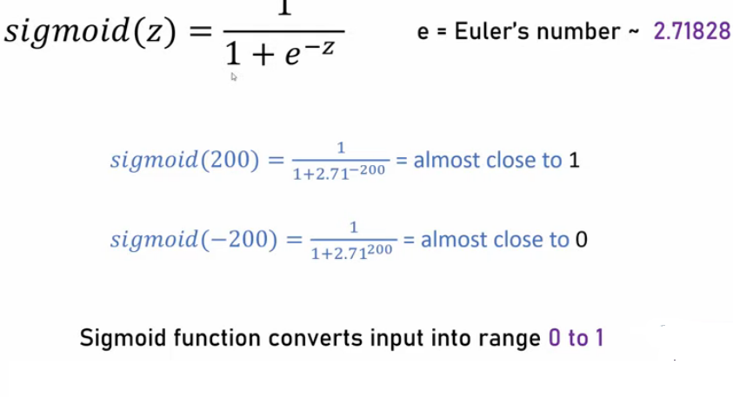
The sigmoid function takes any input value and converts it into a range between 0 and 1.
- For very large positive input values, the sigmoid function outputs a value very close to 1.
- For very large negative input values, the sigmoid function outputs a value very close to 0.
In simple terms, the sigmoid function "squeezes" all input values into the range of 0 to 1, regardless of how big or small the values are.
Summary: Linear line is drawn using linear regression and sigmoid function is applied on linear line and convert it into S shaped, which is better for classification problem.

How Logistic Regression Uses the Sigmoid Function
- Start with a Linear Equation:
The base equation for a straight line is: 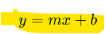
Here, m is the slope and b is the intercept.
- Apply the Sigmoid (logistic) Function:
By passing this linear equation into the sigmoid function, the output is transformed into the range of 0 to 1. The result is an S-shaped curve.
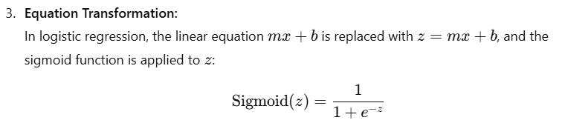
This turns our straight line into a smooth S-shaped curve (called the logistic curve). This transformation converts the linear line into an S-shaped curve that is better for our classification problem and can effectively model probabilities for classification tasks.

This process shows how logistic regression combines the simplicity of a linear model with the flexibility of the sigmoid function to handle classification problems effectively.
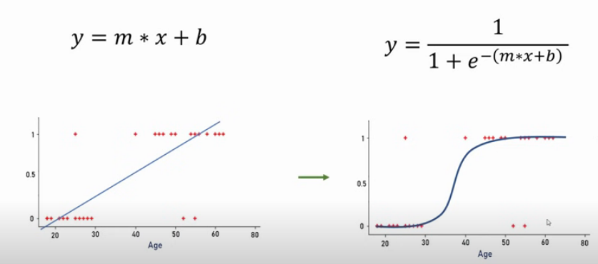

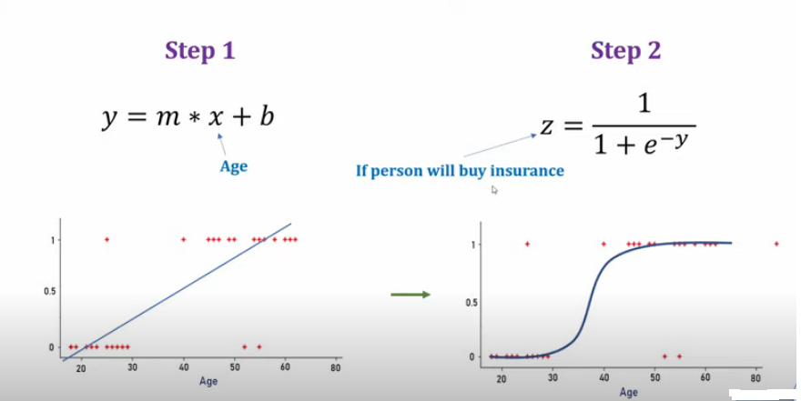

When working on a classification problem like this, the goal is to predict one of two possible outcomes:
- 0: The person will not buy insurance.
- 1: The person will buy insurance.
You are only interested in these two outputs, making it a binary classification problem.
Sigmoid function helps you with the classification problem; value <0.5 is zero (person will not buy insurance), anything >=0.5 z=1 (Person will buy insurance)

Logistic Regression Starts With a Linear Equation
Logistic regression begins with the same linear part as linear regression:
$$z=mx+b$$
This $z$is a linear combination of the input features (like “age”, “income”, etc.).
So yes, the first step is linear — it calculates a straight-line relationship between input and output.

🧩 Then Applies the Sigmoid Function
After that, instead of using $z$directly (as linear regression does), logistic regression passes it through the sigmoid function:
$$P(y=1∣x)=\frac{1}{1+e^{-z}}=\frac{1}{1+e^{-(mx+b)}}$$
This step transforms the straight line (which can go from −∞ to +∞) into a smooth S-shaped curve that always outputs values between 0 and 1.
That curve now represents probabilities:
- Close to 1 → “Yes, will buy insurance”
- Close to 0 → “No, won’t buy insurance”
- Around 0.5 → “Uncertain / boundary case”

🔍 In Simple Words
You can think of logistic regression as a two-step process:
- Linear Step: Compute a weighted sum of inputs (like linear regression).
→ gives $z=mx+b$
- Non-linear (Sigmoid) Step: Convert $z$into a probability using the sigmoid function.
→ gives $P(y=1∣x)$between 0 and 1.
So yes — it first forms a linear equation, then applies the sigmoid function to make it suitable for classification.

🧠 Analogy
Think of it like:
- Step 1: Draw a straight line (linear regression part)
- Step 2: Bend it smoothly into an “S” shape (sigmoid function)
- Step 3: Use that S-shaped curve to decide “yes/no” based on a threshold (like 0.5)

